JUNE 2021
In April, the league celebrated its 67th birthday.
In 1954 Joan Williams and a few friends had the idea of setting up the League of Friends to support the local hospital.
The first committee was established with President Mr Earnest Hutchings, Chairman Mr B Venn Dunn, Secretary Mr J Hutchings, Treasurers Mrs Joan Williams & Mr E M G Cooke, Linen League Organisers Mrs G T Allerton.
Since its inception there has been 9 Presidents, 30 Chairman, only 4 secretaries, 8 Treasurers and 5 Linen League Organisers.
In 1954 we donated £164 for fruit bowls and pictures.
Since then, the equipment provided has ranged from small items costing a few pounds, to £1.3 million for Endoscopy, £1.6 million for Critical Care, and the latest project which is £1.5 million for the Emergency department
The total given to the hospital now stands at over £22 million!
Our latest President Miss Patricia Roberts has been involved with the league since at least 1963 when she became the Telephone Trolley Organiser.
Joan Williams was very active for the league even to the point of go karting at Newton Abbot, so far, we have managed to get Pat Roberts bowling and quizzes, we have suggested other activities which she is thinking of.
Due to building developments, the League has unfortunately lost its Café and Office on Level 2.
We are planning a new office from where we can continue our good work
Unlike several charities who pay activities and events organisers up to 20 thousand pounds all the committee members of the management team and all of the events team give up their time for free this way we can keep up our promise of donating 95 pence in the pound.
Here are a few photos of some of our past events.
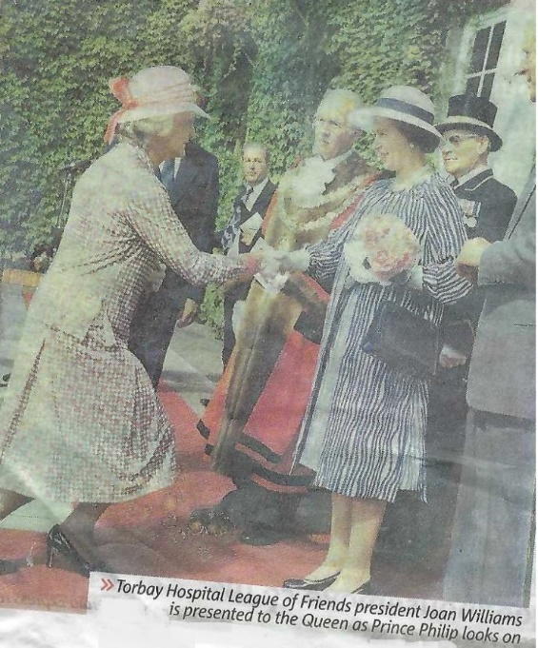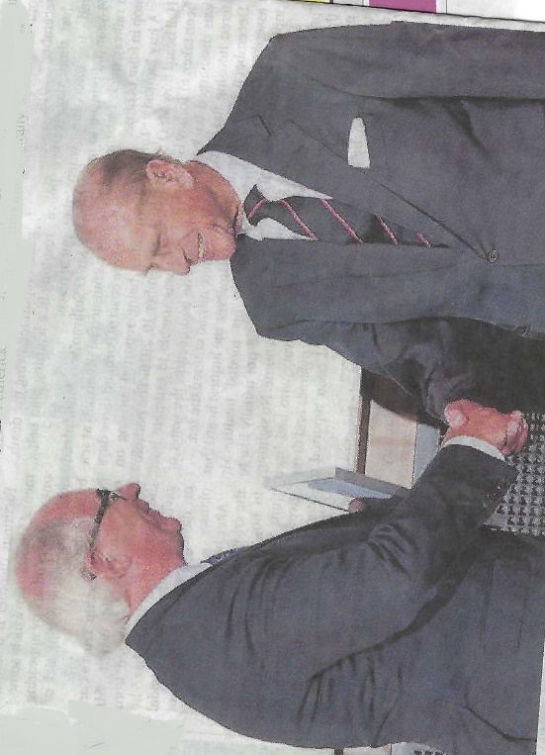

Ground breaking for the new reception and CCU and celebrating the completion of the appeal
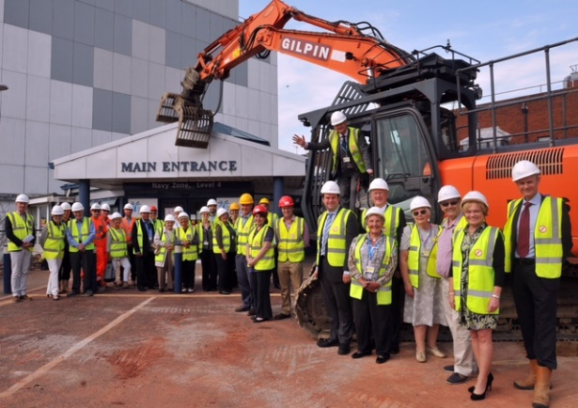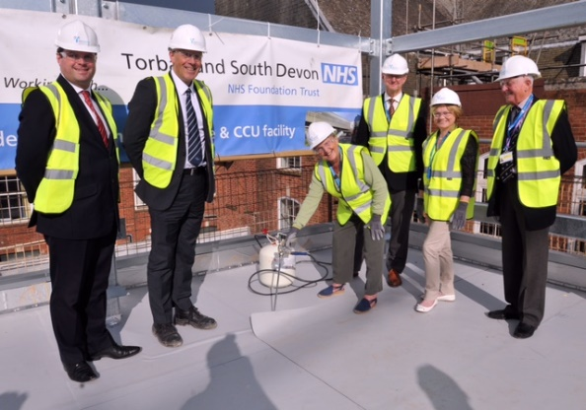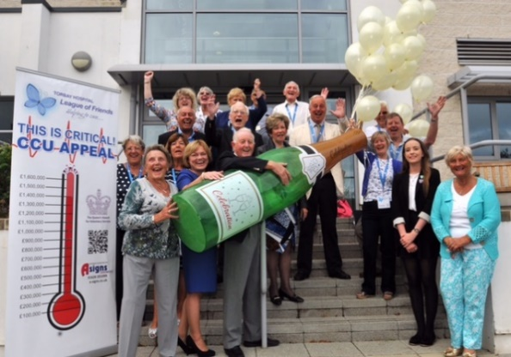
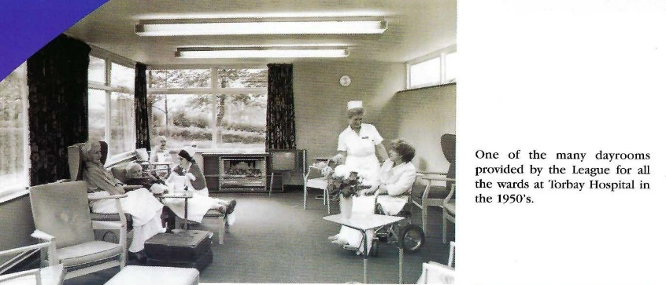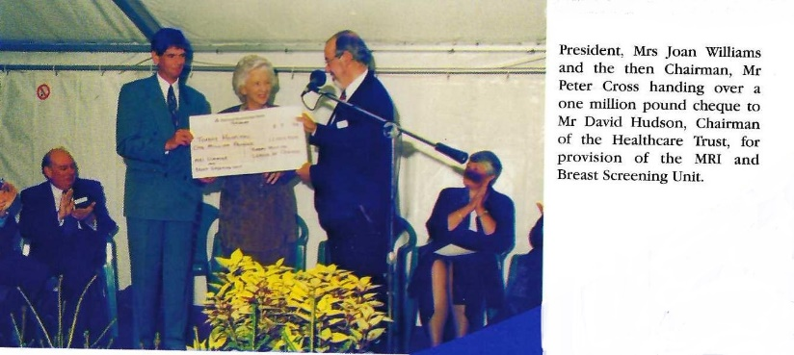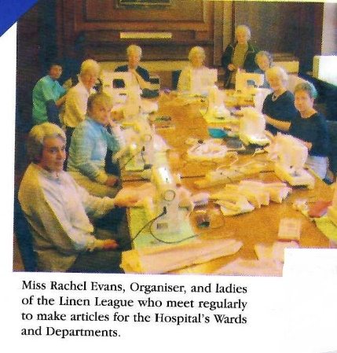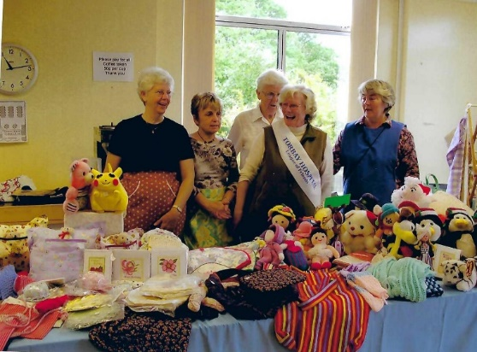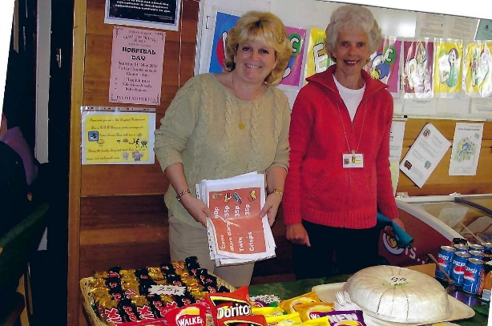

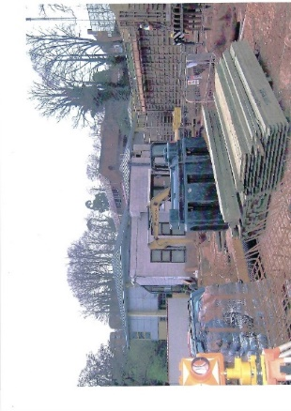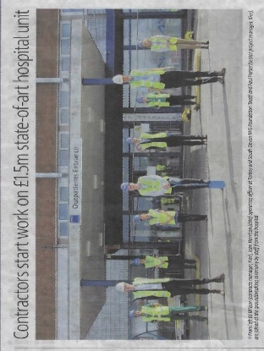

The start of the new Horizon Centre and Kier Builders ready to Break Ground for the new AMU

Joan Williams and Pat Roberts has been presented to Queen Elizabeth II and or the late Prince Philip
while several others have attended a garden party and Buckingham Palace where the League was awarded the QAVS

Why not become a member of the league and receive first hand news on league activities

Why not forward this email to several people and if you have received it from them why not email us on info@thlof.co.uk

We recently held our AGM, at which Roy Tuttle was appointed Chairman, following on from Kathryn Westaway, and Patricia Roberts was re-elected as President.

In previous years we have held a garden parties firstly on the hospital site, and then at the Palace Hotel, Babbacombe.
We were fortunate to have many personalities open the garden parties including Jill Dando, Michael Aspell, Eric Morecombe, Judy Spiers, Kenneth Kendall, Judith Chalmers, Richard Baker, Larry Grayson, Dickie Henderson, Ray Readon and The Krankies to name just a few.
Palm FM Staff 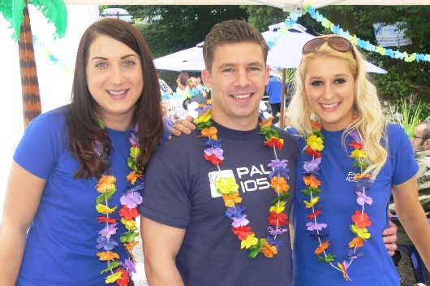 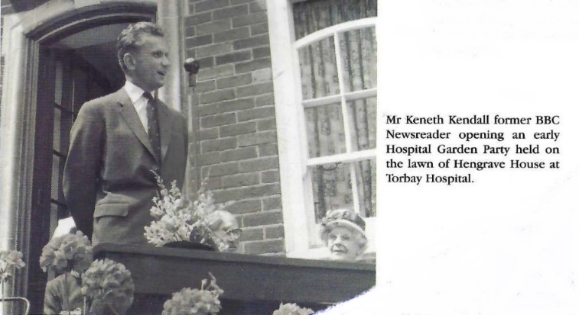
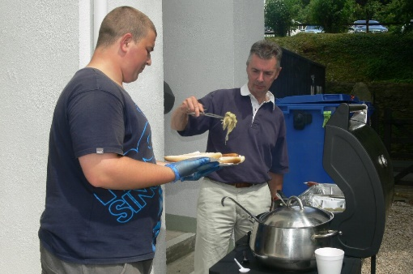 Garden Party Volunteers 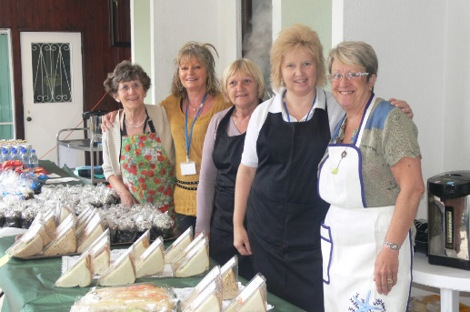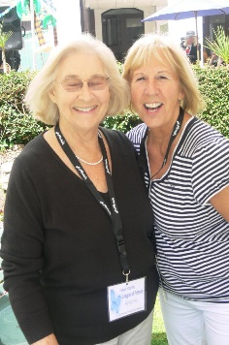
Ray Readon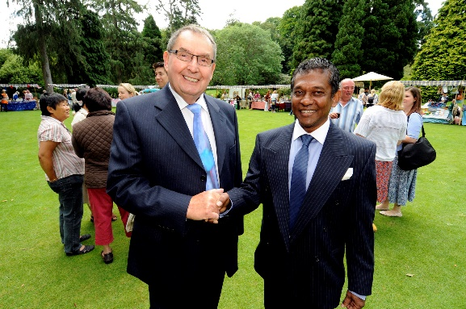 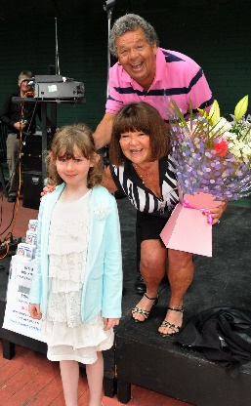 The Krankies
Over the years we have held events, Bowls Night, Quiz Nights, Italian Night, sale and fashion, we also attend Rotary Day on the Downs and The Holiday Network Fun Day. Recently we have organised on August Bank Holiday Sunday a bed push when we push a hospital bed along the Torquay Sea Front from the Grand Hotel to around the Marina and back able supported by members of the Management Team, friend and Directors of the Hospital Management team

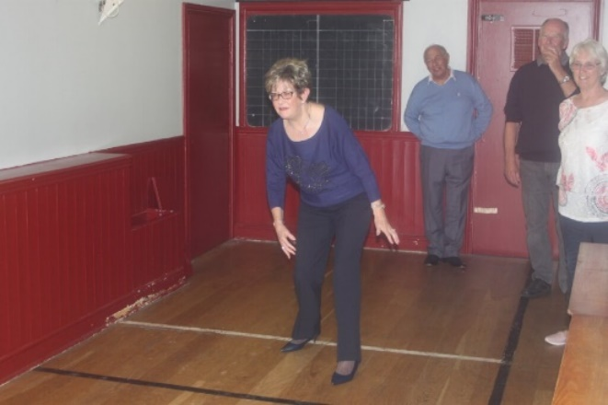Bowls Night at Boots and Laces, Torquay Football Club
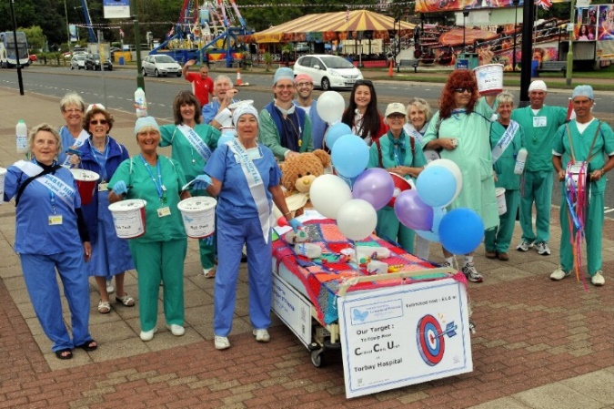Bed Push 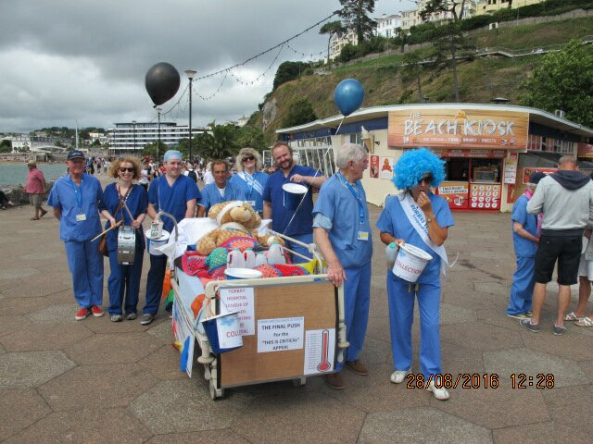
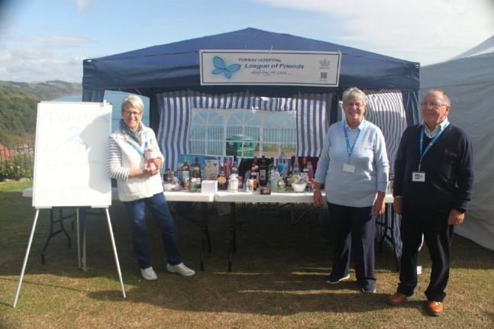Holiday Network Fun Day on the Downs
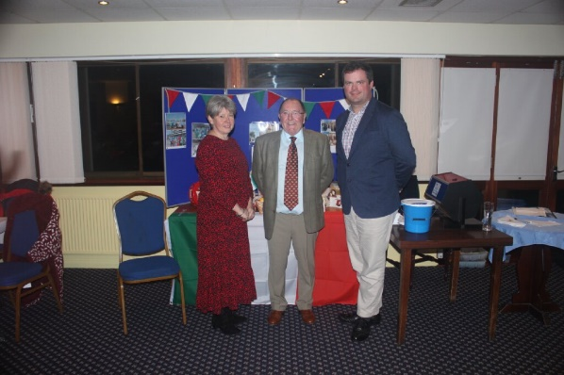Italian Night 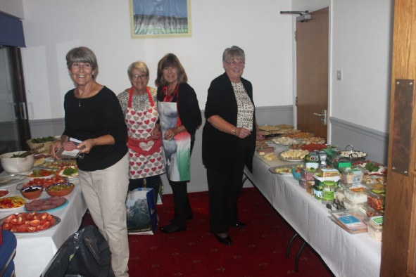
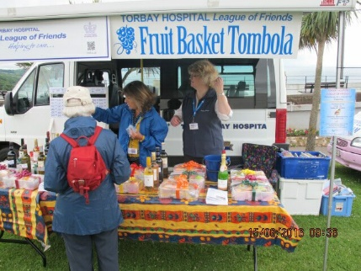Rotary Day on the Downs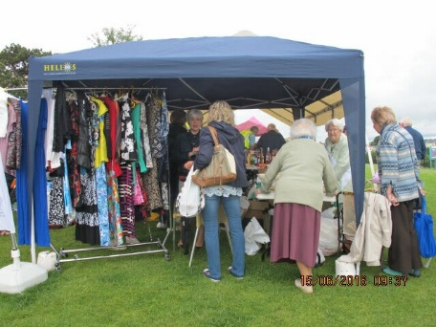
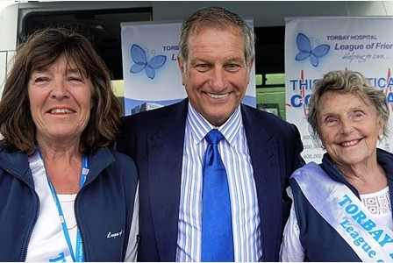At the races with Bob champion

We have a great many supporters around the area, and we would like to thank them for their past and future help
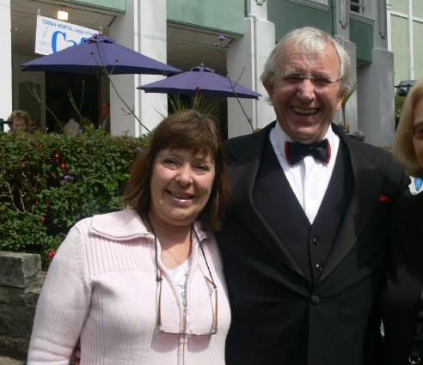Peter “MAC” Dell 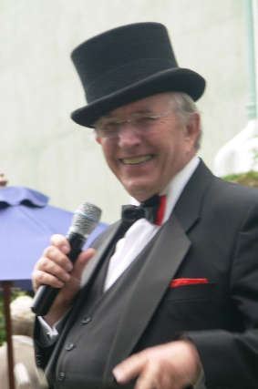 Sandy Sparkle
Also AMICI Italian Restaurant, Hare and Hounds Kingkerswell, and Photographer Paul Levie
Support the league in other ways
Do you shop by Amazon or Amazon Prime then add Amazon Smile to your account
Just go into your account and sign up to smile, when asked which charity you wish to support put down Torbay Hospital League of Friends and Amazon will donate a percentage to us, it will not cost you anything just the knowledge you are supporting a very worthy cause.
Most of us enjoy a little gamble whether it’s the national lottery, scratch card or horses well if you sign up to the Torbay Lottery you are able to say where your donation goes to.
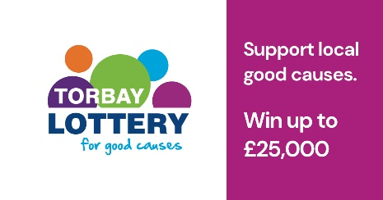
It does not cost any extra and you could win prizes up to £25,00
Soon our new desk on level 4 will be open so please start you collecting of Pennies in plastic
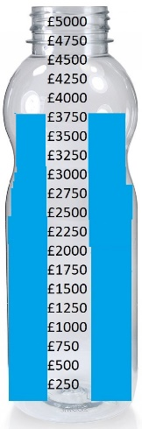
We accept any type of container and any coinage
This month we pledged to give the cardiac department 5 Alivecor Heart Rhythm Monitors, these will be used within the community to monitor patients.
